**Ministerio de Educación**

**Dirección Regional de Educación Particular**

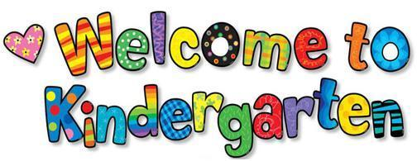

**Centro Bilingüe Bellas Luces**

**Teacher Arantxa Tejeira**

**English Class**

**Kindergarten A-B**

**Worksheets from March 23rd to 27th**

**CAREFULLY READ THE DIRECTIONS.**

**Cada hoja de trabajo debe ser impresa y entregada en un folder e identificado con el nombre de cada estudiante. (En un folder por motivos de que el cuaderno quedo en el colegio) Entregarse al regresar a clases. Se evaluara de forma oral cada tema al regresar a clases.**

1. **Review numbers**

|  |  |
| --- | --- |
| **Days** | March 23rd– March 24th |
| **Lesson objective** | * Count from 1 to 14. * Recognize each numbers. |
| **Key language** | 1,2,3,4,5,6,7,8,9,10,11,12,13,14  Name’s numbers |

**Wokrsheet to do:**

* 1. Count the apples and trace the correct number. Color the apples.
  2. Practice counting

1. **Classroom objects**

|  |  |
| --- | --- |
| **Days** | March 25th – March 26th |
| **Lesson objective** | * Learn to name classroom objects * Identify the classroom objects * Learn three classroom actions |
| **Key language** | Glue, paintbrush, scissor , pasting, painting, cutting |

**Worksheet to do:**

* 1. Trace the lines in different colors and say the actions.
  2. Repeat the actions and show to the student each one.

***‘’I´m painting.’’*** 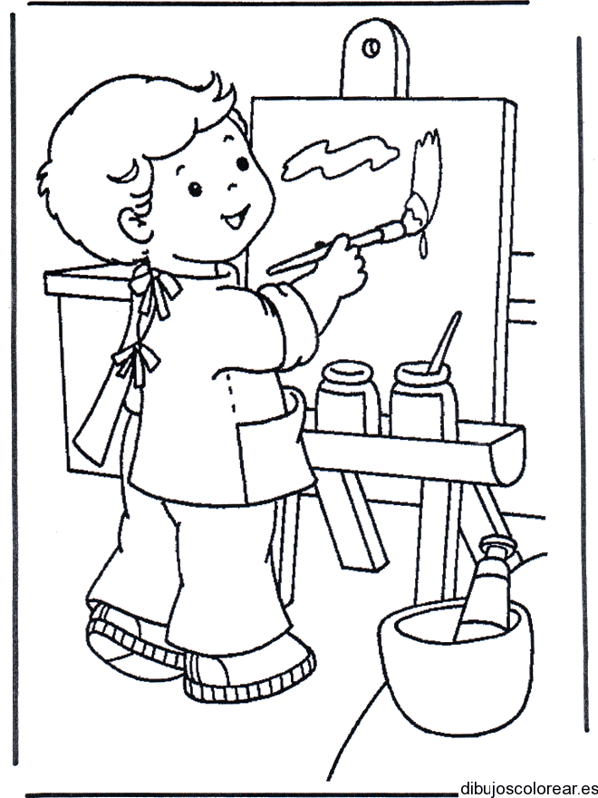

***‘’I’m pasting.’’*** 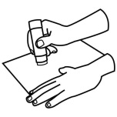

***‘’I’m cutting.’’*** 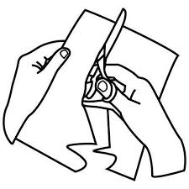

**1.1 Wokrsheet**

**1. Review the numbers**

Count the apples and trace the correct number. Color the apples.

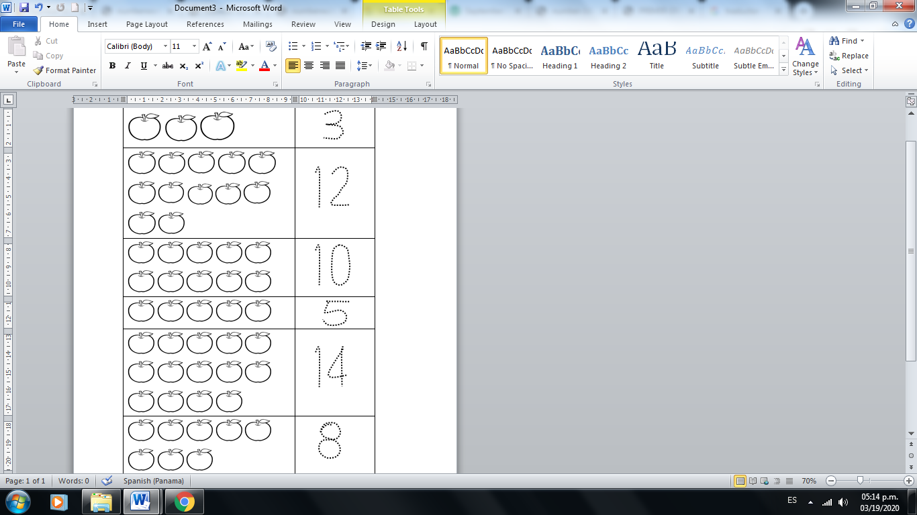

**2.1 Worksheet**

**Classroom objects**

Trace the lines in different colors and say the actions.

