**Ministerio de Educación**

**Dirección Regional de Educación Particular**

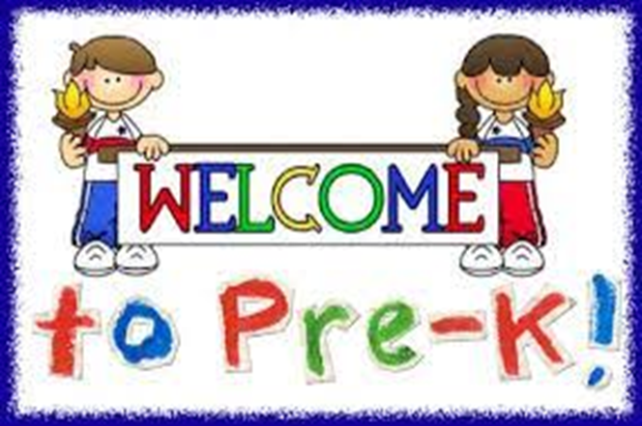

Centro Bilingüe Bellas Luces

Teacher Arantxa Tejeira

English Class

Prekinder A

Worksheets from March 23rd to 27th

**CAREFULLY READ THE DIRECTIONS.**

**Cada hoja de trabajo debe ser impresa y entregada en un folder e identificado con el nombre de cada estudiante. (En un folder por motivos de que el cuaderno quedo en el colegio) Entregarse al regresar a clases. Se evaluara de forma oral cada tema al regresar a clases.**

1. **Numbers 6, 7**

|  |  |
| --- | --- |
| **Day** | Tuesday 24th of March, 2020. |
| **Lesson objective** | * Count to 7 and recognize the numbers until 7. * Be able to count things until 7. |
| **Key language** | 1,2,3,4,5,6,7  Name’s numbers. |

**1.1 Worksheet to do:**

1.1 Count out loud the object around the numbers. Color the objects and paste color torn page. (papel de color rasgado)

1. **Back to school (Unit 1)**

|  |  |
| --- | --- |
| **Day** | Thursday 26th of March, 2020. |
| **Lesson objective** | * Learn to name classroom objects * Identify the classroom objects |
| **Key language** | Backpack, eraser, glue, marker, paintbrush, pencil, pencil case, book |

**2.1 Worksheet to do:**

2.1 Color only classroom objects. Point to and say the name of each object.

**1.1 Worksheet**

**Numbers 6,7**

Count out loud the object around the numbers. Color the objects and paste color torn page. **Please, watch the numbers video from youtube,that I sent by whatsapp.**

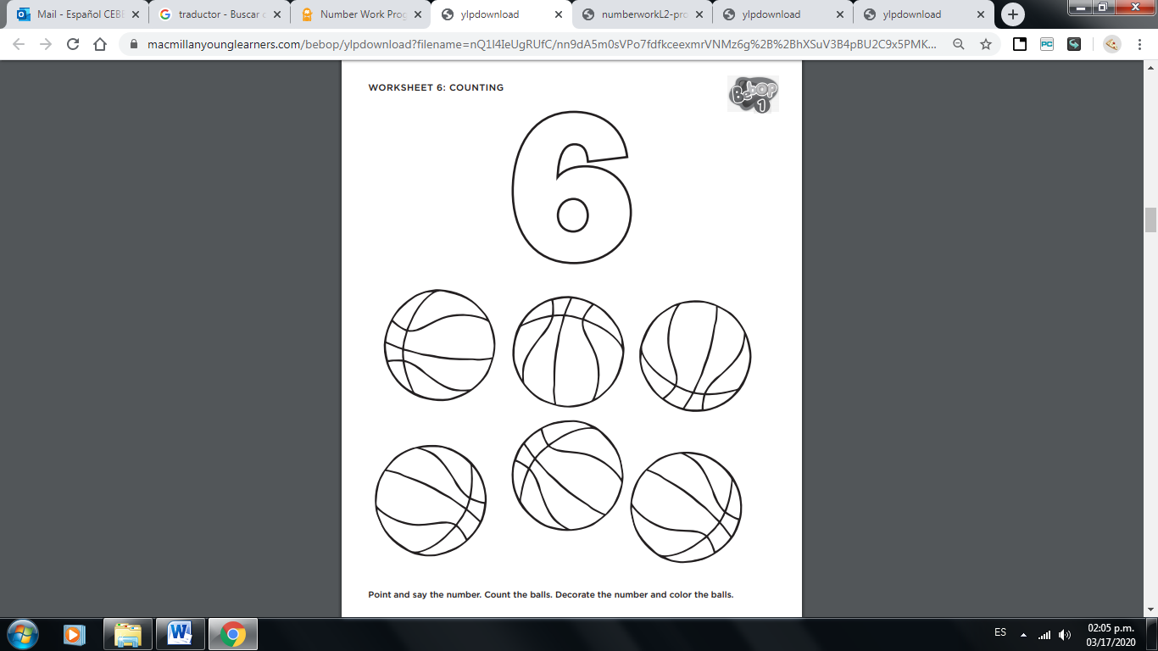

**six**

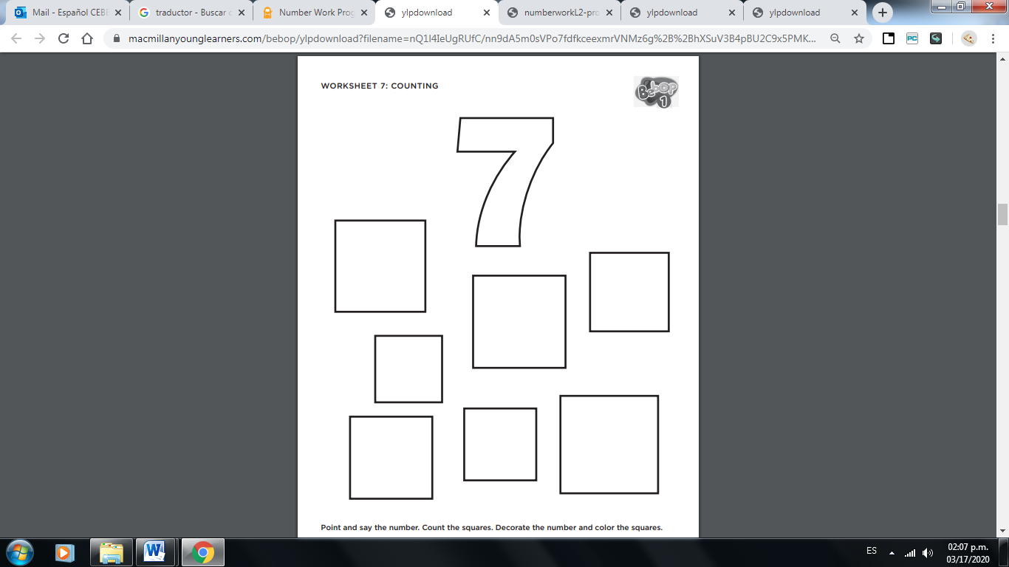

**seven**

**2.1 Worksheet**

**Back to school**

**Classroom objects**

Color only classroom objects. Point to and say the name of each object. (**Backpack, eraser, paintbrush, pencil, pencil case, book)**

