

**Centro Bilingüe Bellas Luces**

**Teacher Arantxa Tejeira**

**Kindergarten A-B**

**Worksheets from March13 to 20.**

**The number 13**

**Repeat the number. Student need to identify the number.** **The student must learn it.**

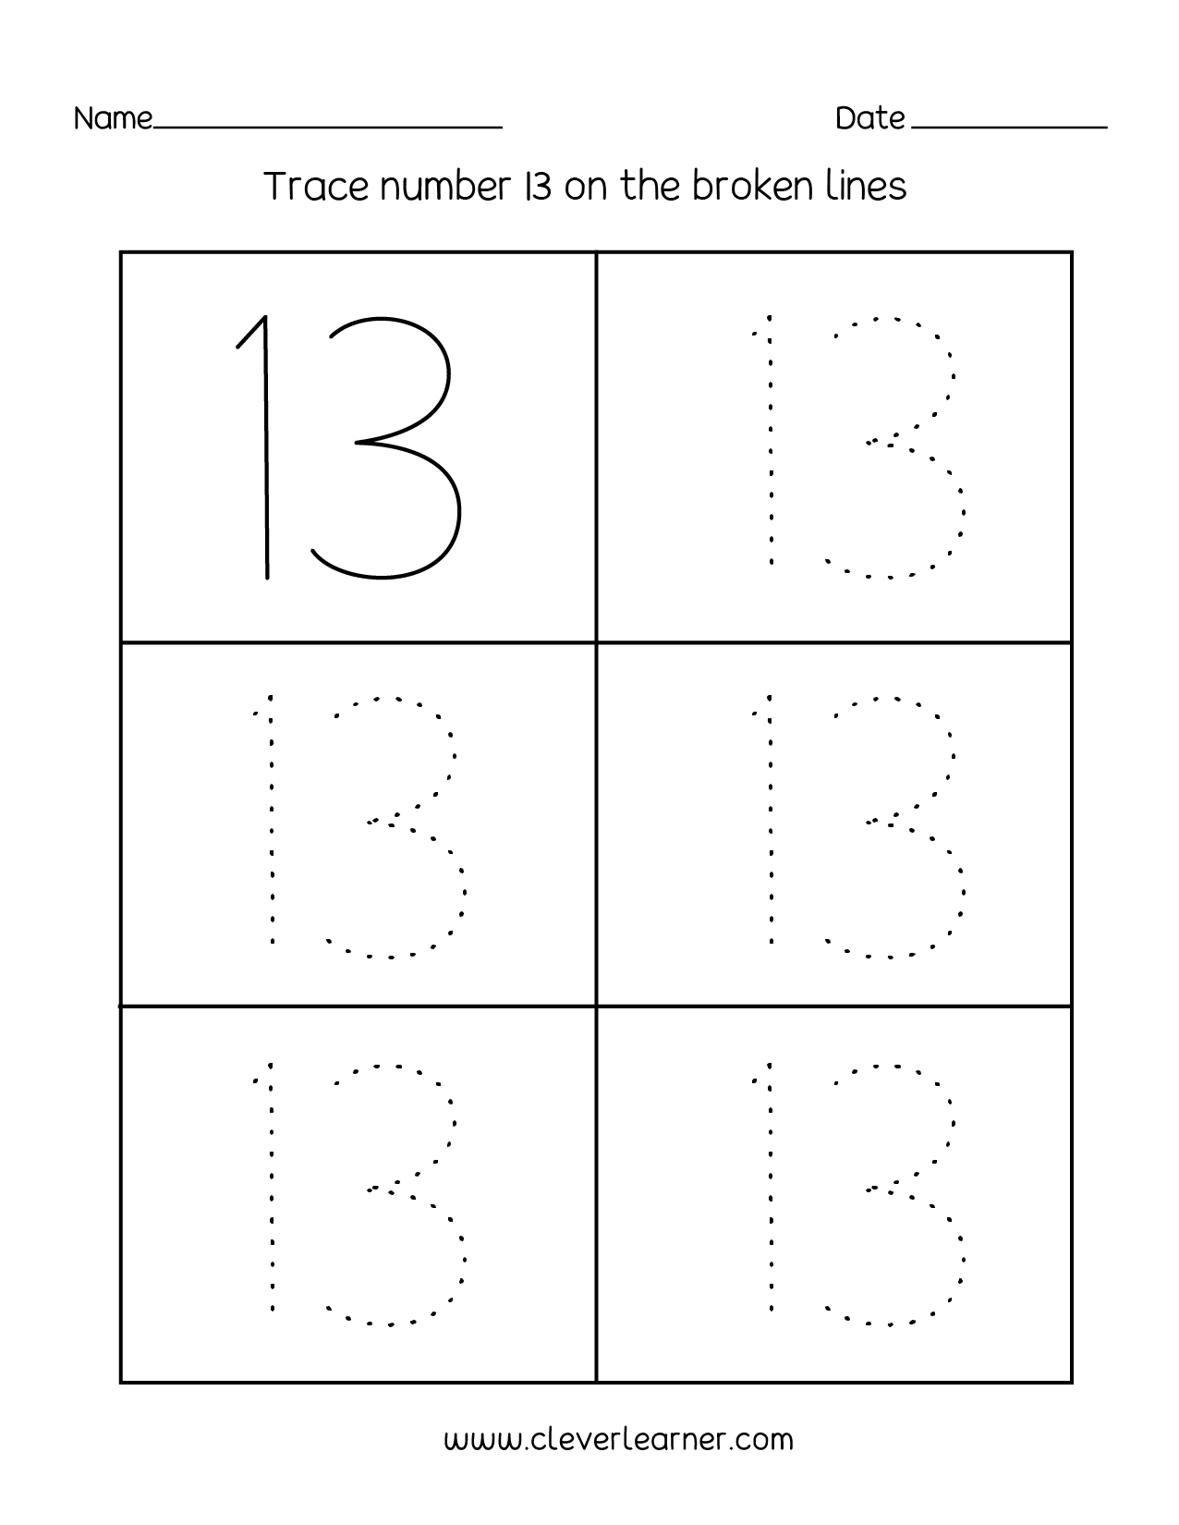

**The number 13**

**Circle and color the things has the number 13.**

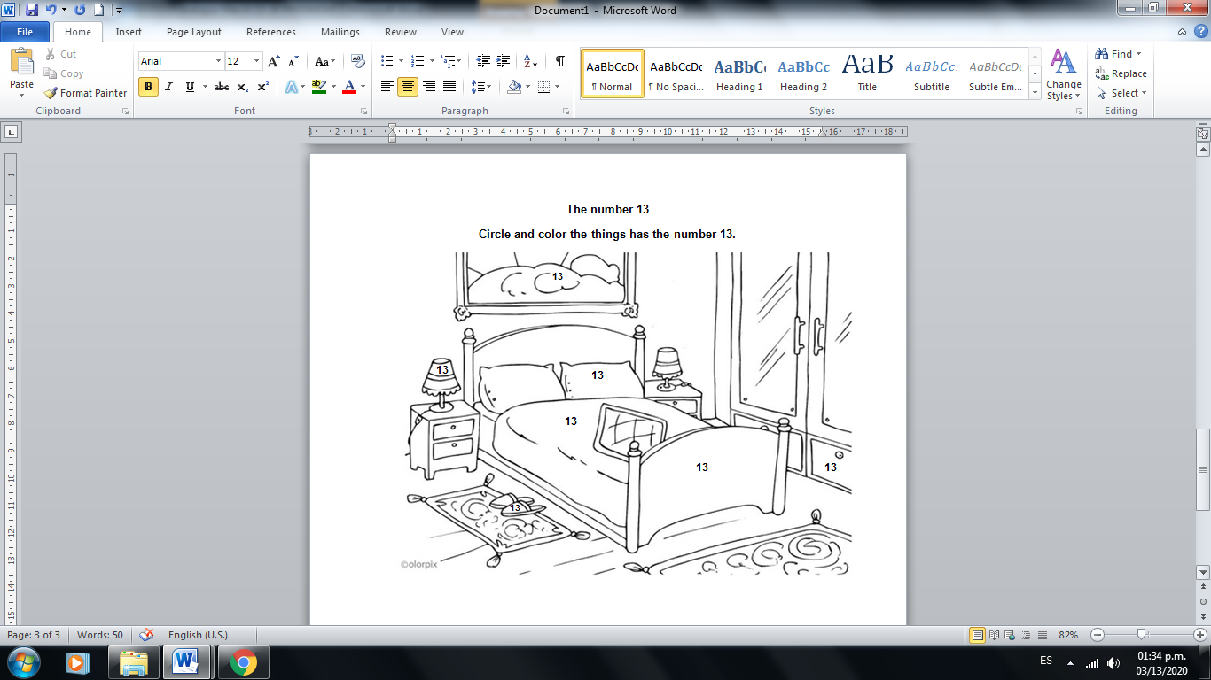

**The number 14**

**Repeat the number fourteen. Color the number and the 14 apples.**