MINISTRY OF EDUCATION

EDUCATIONAL CENTER BILINGUAL BELLAS LUCES

ENGLISH WORKSHOP

FIRST TRIMESTER

TEACHER:

ERIC MARTINEZ B.

3°

2020

DEVELOPS THE NEXTS POINTS IN A BLANK PAGE

SCIENCE SECTION

MAMMALS AND REPTILES

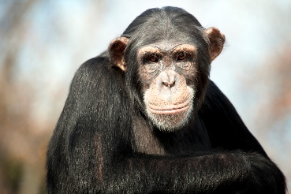

MAMMALS AN REPTILES ARE DIFFERENTS. MAMMALS HAVE FUR OR HAIR.

MAMMALS HAVE LIVE BABIES. BABYS MAMMAÑS DRINK THEIR MOTHER’S MILK.

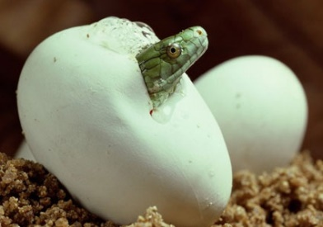

REPTILES HAVE COLD BLOOD. THEY HAVE DRY SKIN OR SCALES.

SOME REPTILES HAVE A SHELL.

MOST REPTILES LAY EGGS.

|  |  |  |  |
| --- | --- | --- | --- |
| CAMALEÓN » Un reptil que destaca por sus múltiples colores | marmoset | Description, Habitat, & Facts | Britannica | Indian Star Tortoises | Newly discovered differences in red panda genes reveal there may ... |
| THIS IS Q CHAMALEON. IT HAS SCALES AND LONG TONGUE. | THIS IS A MARMOSET. IT’S A KIND OF MONKEY. IT HAS GRAY FUR AMD SMALL EYES. | THIS IS A TORTOISE. IT HAS A BEAUTIFUL SHELL. | THIS IS A RED PANDA. IT HAS RED FUR AND A LONG TAIL. |

ACTIVITIES

A. ANSWER THE NEXT QUESTIONS.

1. DO MAMMALS HAVE WARM BLOOD?

____________________________________________________________.

2. WHAT DO BABY MAMMALS DRINK?

____________________________________________________________.

3. DO ALL REPTILES HAVE A SHELL?

____________________________________________________________.

B. TALK ABOUT AN ANIMAL IN THE PICTURES.