MINISTRY OF EDUCATION

REGIONAL DIRECTORATE OF PANAMA WEST

EDUCATIONAL CENTER BILINGUE BELLAS LUCES

ENGLISH WORKSHOP 2

FIRST TRIMESTER

TEACHER:

ERIC MARTINEZ B.

3°

2020

DEVELOPS THE NEXTS POINTS IN A BLANK PAGE.

OBJECTIVE: IDENTIFY AND NAME ANIMAL PARTS OF THE BODY

DESCRIBE AN ANIMAL.

SPELLING SECTION

VOCABULARY- ANIMAL WORLD

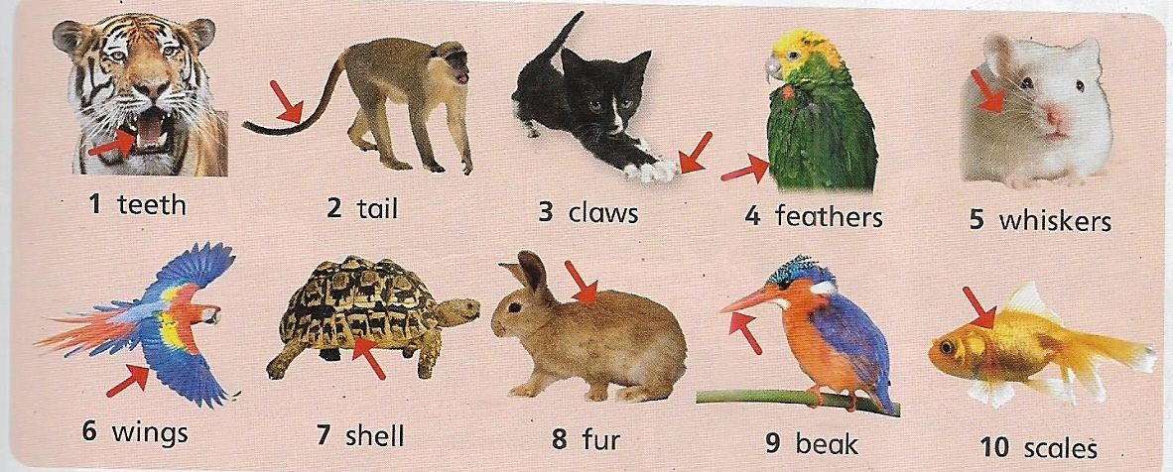

1. TEETH

2. TAIL

3. CLAWS

4. FEATHERS

5. WHISKERS

6. WING

7. SHELL

8. FUR

9. BEAK

10. SCALES

ACTIVITY

1. TAKE 5 WORDS OF VOCABULARY AND CREATE 5 SENTENCES WITH EACH WORDS.

EXAMPLE: *A BIRDS HAS WINGS*

GRAMMAR SECTION

USE OF HAVE IN AFFIRMATIVE AND NEGATIVE IN THIRDS PERSON.

HAS / DOES NOT HAVE(DOESN’T HAVE)

ACTIVITIES

A. COMPLETE AND WRITE SENTENCES WITH THE WORDS. USING HAS TO AFFIRMATIVE AND (DOES NOT) DOESN’T HAVE TO NEGATTIVE.

EXAMPLE: (LIZARD/FUR): THE LIZARD DOESN’T HAVE FUR.

(HAMSTER/WHISKERS): THE HAMSTER HAS WHISKERS.

1. (HAMSTER/FUR): _________________________________________________

2. (LIZARD/FEATHERS): ________________________________________________

3. (RABBIT/ A TAIL): ____________________________________________________

4. (FROG/CLAWS): ______________________________________________________

5. (BIRDS/TEETH): ___________________________________________________

B. CREATE 5 QUESTION. ANSWER YES, IT DOES **OR** NO, IT DOESN’T. DON`T FORGET TO ADD QUESTION MARK.

EXAMPLE QUESTION: (BIRDS): DOES IT HAVE FEATHERS? YES. IT DOES.

(FISH): DOES IT HAVE FUR? NO, IT DOESN’T.

1. (FEATHER): ________________________________ _______________________

2. (FUR): ______________________________ _____________________

3. (A BEAK): ______________________________ ____________________

4. (SCALES): _________________________________ _____________________

5. (A SHELL): __________________________________ _____________________

READING SECTION

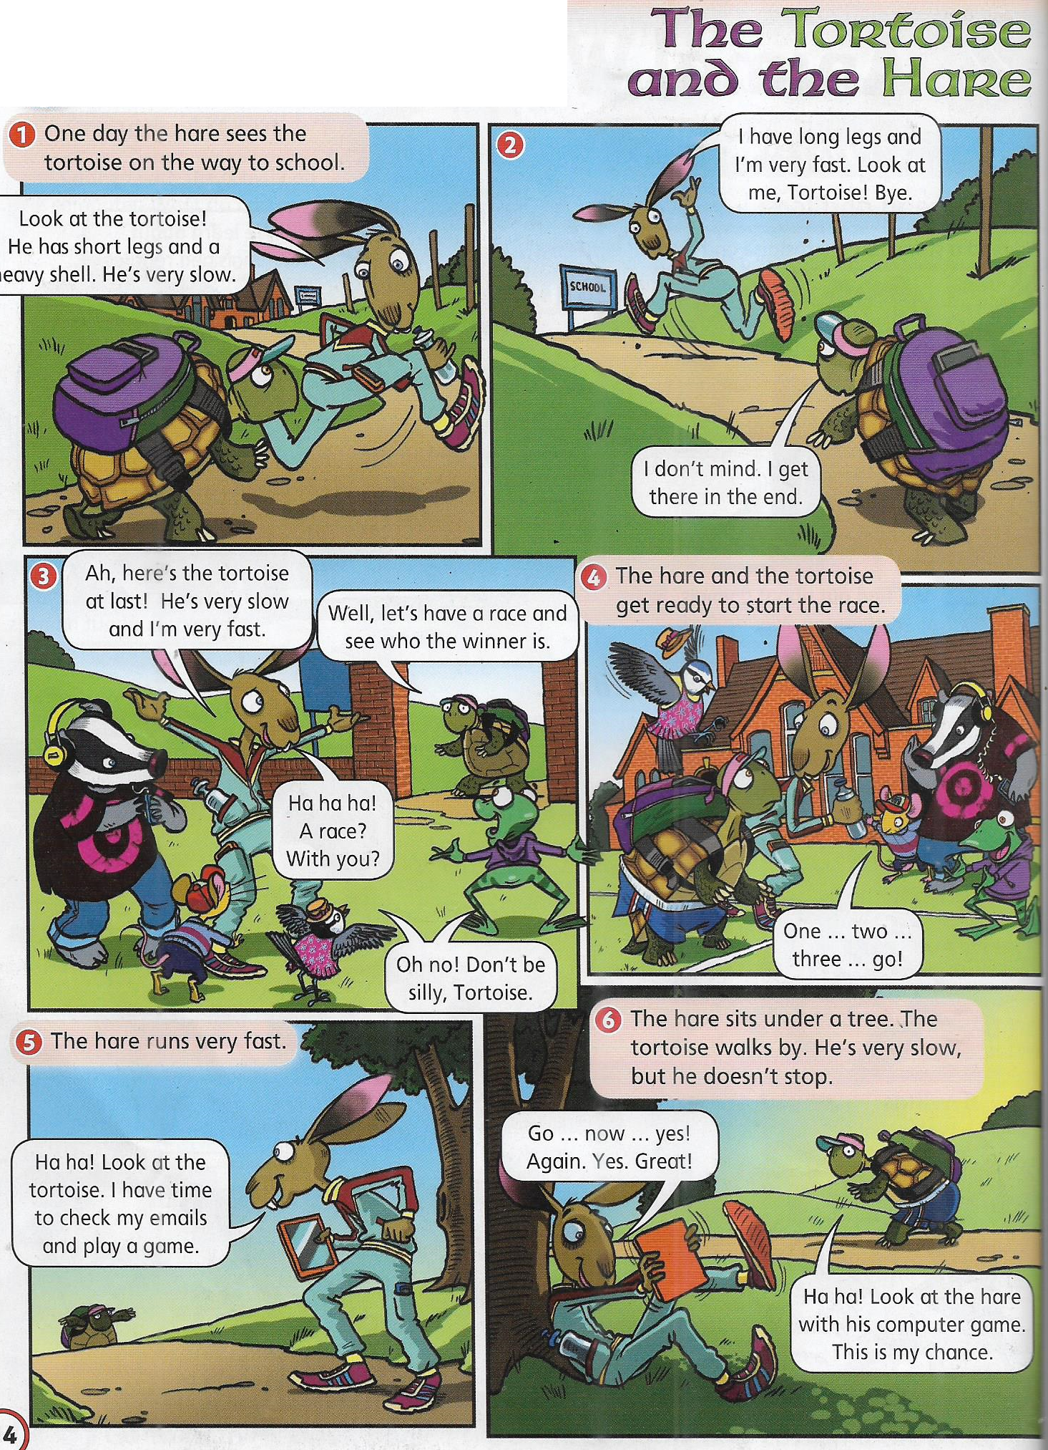

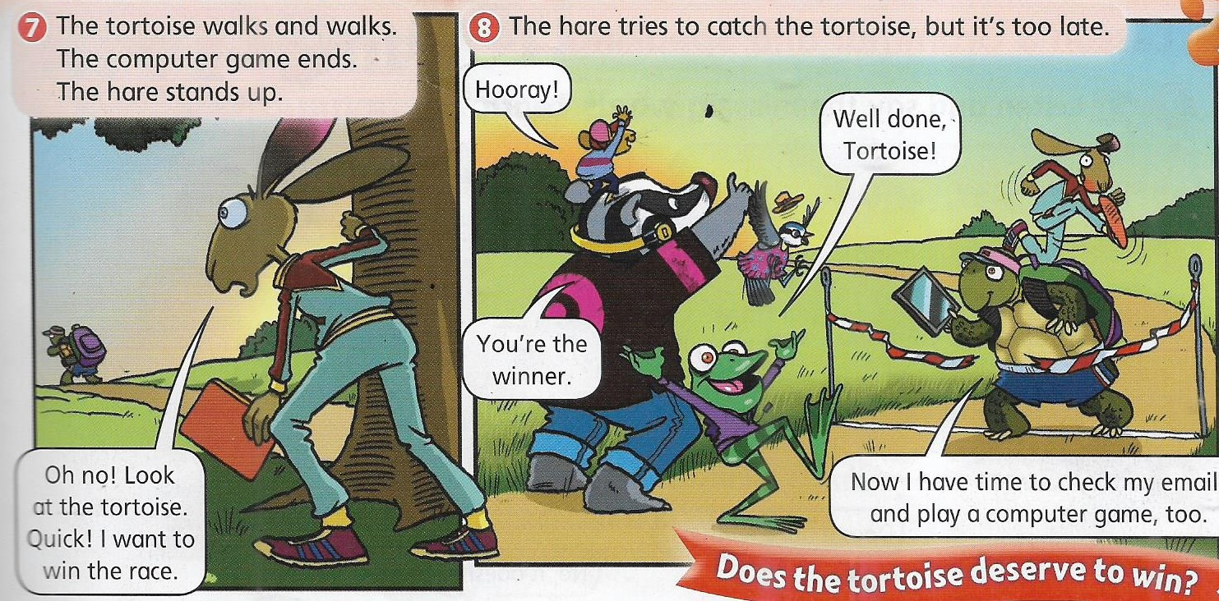

ACTIVITIES

READ THE STORY AND ANSWER THE NEXT QUESTIONS

1. WHO IS FAST? ___________________________________________.

2. WHO JUST CAN WALK? _____________________________________.

3. HE SITS UNDER A TREE _____________________________.

4. WRITE 3 CHARACTERISTICS OF THE TORTOISE

__________________________________________

__________________________________________

__________________________________________

5. WHO WINS THE RACE? _________________________.

[**Génesis 9:9-10**](https://bible.knowing-jesus.com/Espa%C3%B1al/G%C3%A9nesis/9/9)

*“He aquí, yo establezco mi pacto con vosotros, y con vuestra descendencia después de vosotros, y con todo ser viviente que está con vosotros: aves, ganados y todos los animales de la tierra que están con vosotros; todos los que han salido del arca, todos los animales de la tierra.”*