MINISTRY OF EDUCATION

REGIONAL DIRECTORATE OF PANAMA WEST

EDUCATIONAL CENTER BILINGUE BELLAS LUCES

ENGLISH WORKSHOP

FIRST TRIMESTER

TEACHER:

ERIC MARTINEZ B.

3°

TOPICS:

1. USE COMPUTERS

2. MAKE QUESTIONS

3. TECHNOLOGY

2020

DEVELOPS THE NEXTS POINTS IN THEIR NOTEBOOK.

1. USE COMPUTERS: - SPELLING SECTION

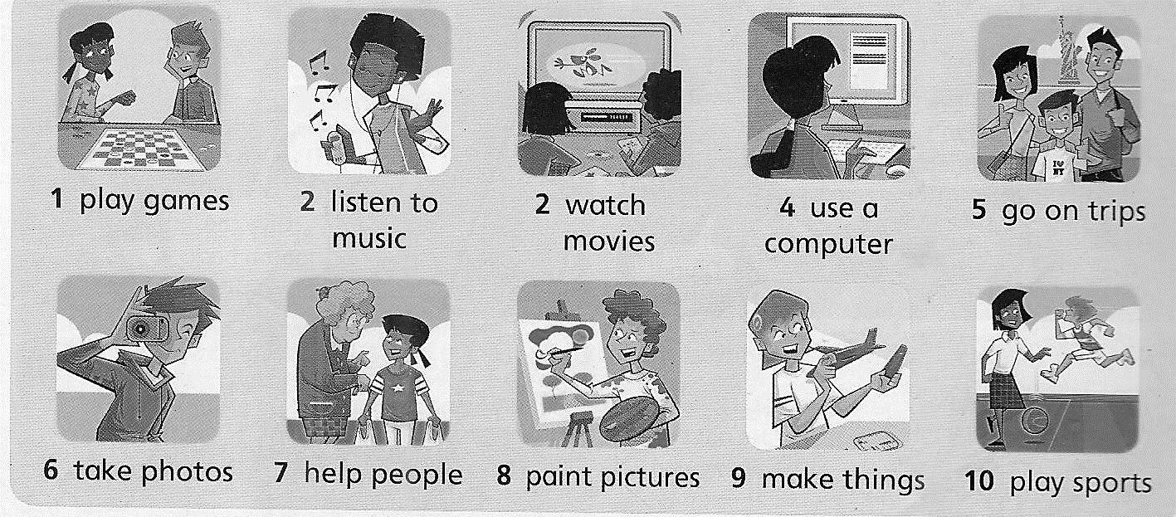

1.1 MAKE A SENTENCE AFFIRMATIVE OR NEGATIVE WITH EACH PHRASE

1.2 INCLUDE YOURSELF (THE KID) IN EACH SENTENCE. EXAMPLE:

AFFIRMATIVE: I PAINT PICTURES.

NEGATIVE: I **DON’T** PLAY SPORTS.

2. MAKE QUESTIONS: GRAMMAR SECTION

WRITE WHAT YOU DO, MAKE QUESTION WITH PHRASES:

EXAMPLE: **DO YOU TAKE PHOTOS? YES, I DO**

**DO YOU HELP PEOPLE?** **NO, I DON’T(DO NOT)**

2.1 WRITE 5 QUESTIONS AND THEIR ANSWERS.

2.2 ORDER THE NEXT QUESTIONS.

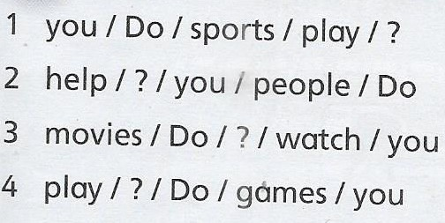

3. TECHNOLOGY: SCIENCE/MATH SECTION

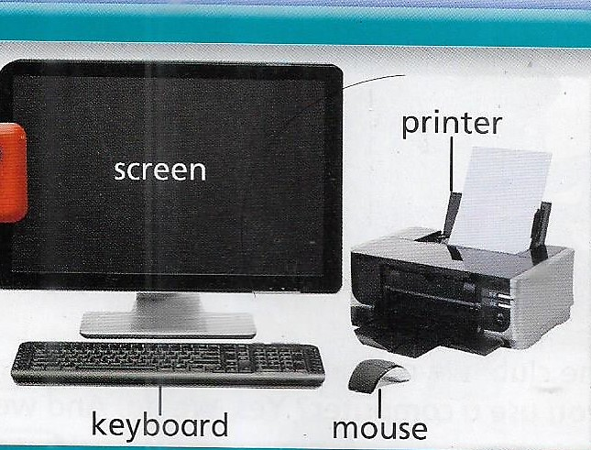

3.1 ORDER THE WORDS.

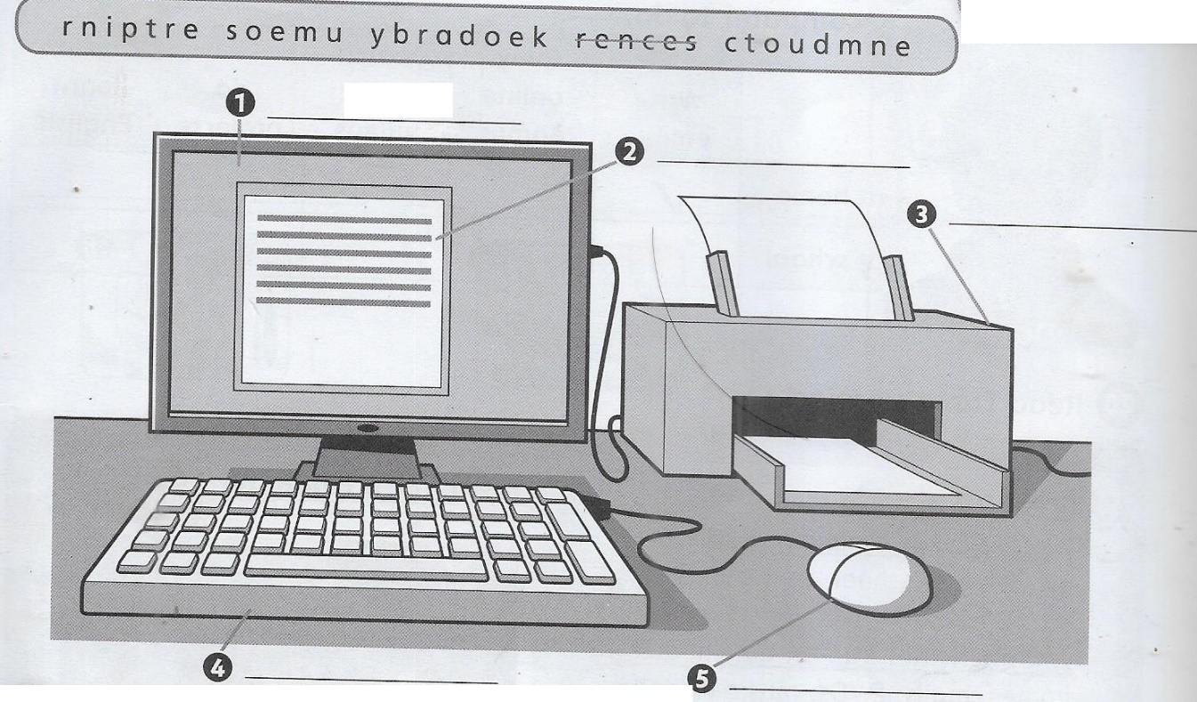

3.2 WRITE A PARAGRAPH ABOUT WHAT YOU USE A COMPUTER TO DO.