MINISTRY OF EDUCATION

REGIONAL DIRECTORATE OF PANAMA WEST

EDUCATIONAL CENTER BILINGUE BELLAS LUCES

ENGLISH WORKSHOP

FIRST TRIMESTER

TEACHER:

ERIC MARTINEZ B.

2°

TOPICS:

1. PARTS OF HOUSE

2. YES/NO QUESTIONS

3. THINGS OF OUR HOME

2020

Develop the assigned points in their notebook, following the instructions given.

1. PARTS OF HOUSE: - **SPELLING SECTION**

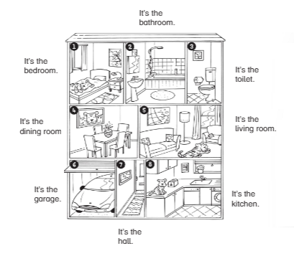

1.1 MAKE A SENTECE OF PARTS OF HOUSE

Examples:

Luis is in the bathroom.

Jason is in the living room.

Robert is in the bedroom.

2. YES/NO QUESTIONS:

Questions:

Structure: Verb be (present simple) + Subject + Complement

Answers: YES, HE/SHE IS. NO, HE/SHE IS NOT.

Example:

-Is Emma in the kitchen? - No, she isn’t (is not).

-Is Javier in the living room? – Yes, he is.

2.1 MAKE 3 YES/NO QUESTION WITH THE PARTS OF HOUSE(EXAMPLE) **GRAMMAR SECTION**

2.2 LOCATION: VOCABULARY

UNDER= DEBAJO

IN= DENTRO

ON= SOBRE

NEXT TO= AL LADO DE

BEHIND= DETRAS

IN FRONT OF= DELANTE DE

IDENTIFY THE LOCATION OF *ED THE ELEPHANT*. DRAW THE LAST TABLE AND WRITE THE SENTECE.

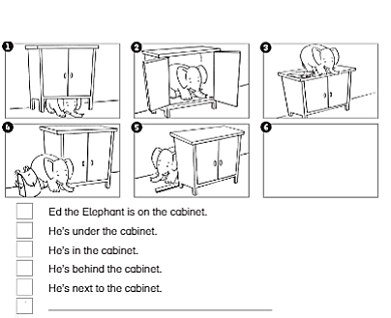

3. THINGS OF OUR HOME: SCIENCE/MATH SECTION

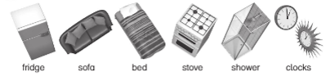

3.1 LOOK, FIND AND WRITE THE NAMES UNDER THE PICTURE.

