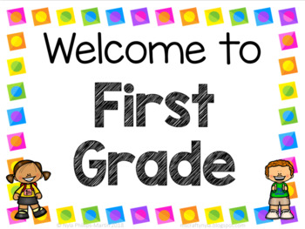

Centro Bilingüe Bellas Luces

Teacher Arantxa Tejeira

1st grade A-B-C

Worksheets from March 13 to 20.

**The Vowels Worksheet**

Repeat the vowel’s name. Say the names of each picture. Color the pictures.

**Name: ____________________________________________**

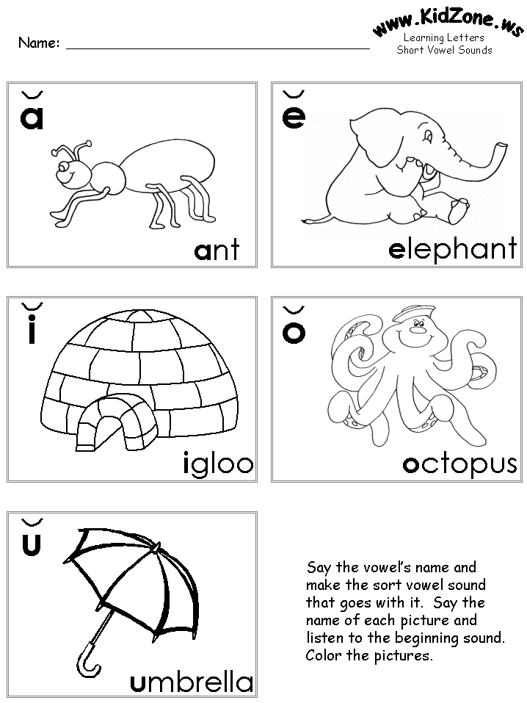

**Which are the Vowels?**

Circle all the vowels inside of the hippo’s mouth.

**Name: ____________________________________________**

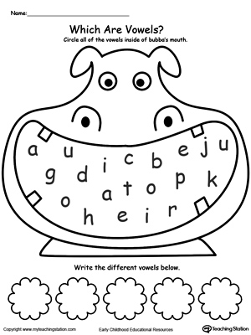

**Write the different vowels below**.

**The Vowels**

Name: ________________________________________________

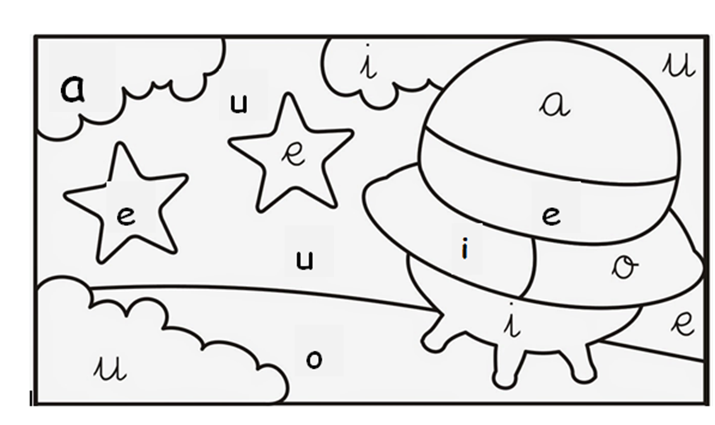

**Color the drawing with the correct color for each vowel.**

a: blue e: yellow i: orange o: brown u: green

**Shapes**

**Match the shapes with things that have a similar shape. Color.**

