**Ministerio de Educación**

**Dirección Regional de Educación Particular**

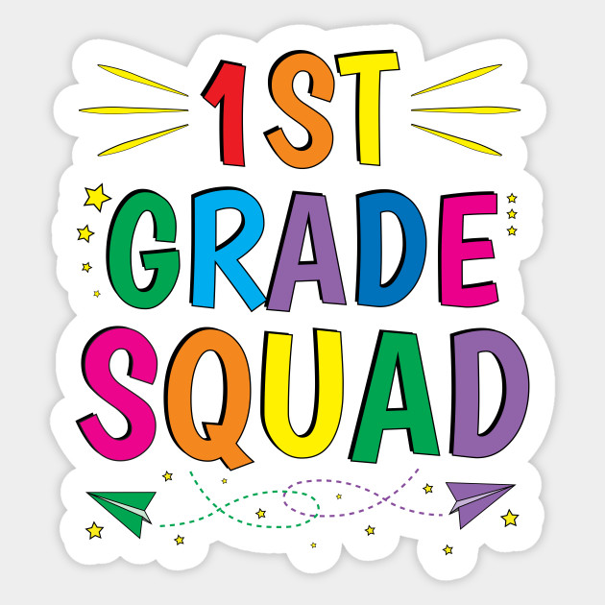

**Centro Bilingüe Bellas Luces**

**Teacher Arantxa Tejeira**

**1st grade A-B-C**

**Subject: Grammar,Reading,Speech, Spelling, Science**

**Worksheets from March 23rd to 27th.**

**CAREFULLY READ THE DIRECTIONS.**

**Cada hoja de trabajo debe ser impresa y entregada en el cuaderno de cada asignatura del estudiante. Entregarse al regresar a clases. Dios nos bendiga a todos (God bless us)**

* **Se evaluara cada actividad al regresar a clases.**

**Nota: Solo debe imprimir las actividades que necesiten ser impresa. Las que son en el cuaderno solo deben ser realizada en el cuaderno.**

***GRAMMAR / READING***

1. **Greetings, introductions and farewells**

|  |  |
| --- | --- |
| **Days** | Monday 23rd of March, 2020  Tuesday 24th of March, 2020 |
| **Lesson objective** | * Ask and say your name and age * To listen and say correct greetings |
| **Key language** | Hi, hello, good morning, bye-see you , what’s your name?, my name is…, how old are you?, I’m (six) |

**Worksheet to do:**

* 1. Draw me. Answer my personal info.
  2. Match the picture with their correct greetings and farewells.

**Greetings:** (saludos)

Hi- Hello= Hola

Good morning= Buenos días

**Introductions:** (presentación)

What’s your name? = ¿Cual es tu nombre?

My name is… = Mi nombre es…

How old are you? = ¿Cuántos años tienes?

I’m (six) = Tengo (seis)

**Farewells:** (despedidas)

Bye- see you= Adios – Nos vemos.

*Explain to the student each word to make the correct use of them and identify them.*

**SPELLING / SPEECH**

1. **Short vowel A**

|  |  |
| --- | --- |
| **Days** | Wednesday 25th of March, 2020 |
| **Lesson objective** | * Practice the pronunciation of short ´´a´´ * Recognize and read key words |
| **Key language** | Bag, man, hat, can, van, apple, cat, angry |

**Worksheet to do:**

* 1. In the Spelling notebook write the vocabulary words. And then write them each 5 times.
  2. Illustrated each words

**Phonic short A**

In English, phonetics teaches us the sound of letters. This opportunity we will learn one of the sounds of the vowel a. The vowel has a long and short sound. We will be learning about the short sound. **THE SHORT *A* SOUNDS** **IS LIKE *A* IN Spanish.** (AAA)

**SCIENCE**

1. **My family**

|  |  |
| --- | --- |
| **Days** | Thursday 26th of March, 2020  Friday 27th of March, 2020 |
| **Lesson objective** | * Talks about his/her family * Uses the correct word to identify family members |
| **Key language** | Mother, father, sister, brother, baby, grandma, grandpa |

**Worksheet to do:**

* 1. Draw in their science notebook his/her family and write the name of each member. (Example: if I draw a woman, I identify it like mother)
  2. On the family tree worksheet write the name of each member of your family.

**The Family**

Family is the most important. The family will always be there for us and it is where we will always have love and affection. We must love our parents, grandparents and brothers/sisters.

**Who are the members?**

* 1. **Worksheet**

**My introduction**

Draw me. Answer my personal info.

Whats your name?

How old are you?



* 1. **Worksheet**

**Greetings and farewells**

Match the picture with their correct greetings and farewells. 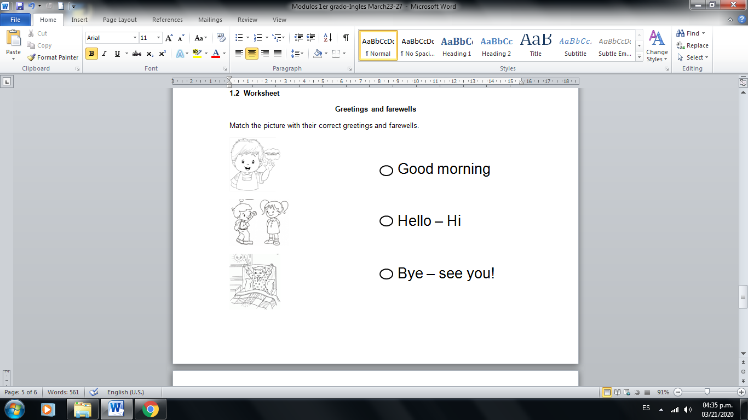

**2.1 Worksheet**

**Short Vowel A**

In the Spelling notebook write the vocabulary words. And then write them each 5 times. It must be written in the student's handwriting.

1. Bag
2. man
3. hat
4. hand
5. black
6. apple
7. cat
8. angry

* **Illustrated each words**

**3.1 Worksheet**

**My family**

Draw in their **science notebook** his/her family and write the name of each member. (Example: if I draw a woman, I identify it like mother)

**3.2 Worksheet**

**My Family Tree**

On the family tree worksheet write the name of each member of your family. (Based on your family)

