**Ministerio de Educación**

**Dirección Regional de Educación Particular**



**Centro Bilingüe Bellas Luces**

**Teacher Arantxa Tejeira**

**1st grade A-B-C**

**Subject: Grammar,Reading,Speech, Spelling, Math**

**Worksheets from March 30th to April 3rd.**

**CAREFULLY READ THE DIRECTIONS.**

**Cada hoja de trabajo debe ser impresa y entregada en el cuaderno de cada asignatura del estudiante. Entregarse al regresar a clases. Dios nos bendiga a todos (God bless us)**

* **Se evaluara cada actividad al regresar a clases.**

**Nota: Solo debe imprimir las actividades que necesiten ser impresa. Las que son en el cuaderno solo deben ser realizadas en el cuaderno.**

*GRAMMAR / READING*

4. **Personal Pronouns**

|  |  |
| --- | --- |
| **Days** | Monday 30th of March, 2020  Tuesday 31st of March, 2020 |
| **Lesson objective** | * Identify each personal pronouns * Learn how to use them correctly |
| **Key language** | I, you, she, he, they |

**Worksheet to do:**

4.1 Write the correct pronoun for each picture

4.2 Replace with the pronouns in each sentence.

**Personal pronouns**

The personal pronouns are:

I = Yo

You= Tu

She= Ella

He= Él

They= Ellos/Ellas

*SPELLING / SPEECH*

5. **Sound vowels (long vowel sounds)**

|  |  |
| --- | --- |
| **Days** | Wednesday 1st of April, 2020 |
| **Lesson objective** | * Practice pronunciation of long vowel sound * Improve our vocabulary |
| **Key language** | A (ai) , E (ii), I (ai), O (ou), U (iu)  Angel, ear, ice cream, ocean, unicycle |

**Worksheet to do:**

5.1 Color the picture of each vowel and repeat the name pictures.

5.2 Match the vowel to the picture

**The vowels**

For this lesson topic we need to learn the long vowel sound of each vowel.

Example: A- Angle , E- Ear, I- Ice cream, O- Ocean, U- Unicycle

***For an example of sound watch the video sent by the teacher.***

*MATH*

**6. Days of the week**

|  |  |
| --- | --- |
| **Days** | Thursday 2nd of March, 2020  Friday 3rd of March, 2020 |
| **Lesson objective** | * Learn the days * Learn the order of the days |
| **Key language** | Monday, Tuesday, Wednesday, Thursday, Friday, Saturday, Sunday |

**Worksheet to do:**

6.1 On the Math notebook draw a chart and write the days in order.

6.2 Follow the sequence. Need to write the day is next on the sequence.

**Example of the chart:**

|  |  |  |  |  |  |  |
| --- | --- | --- | --- | --- | --- | --- |
| **DAYS OF THE WEEK** | | | | | | |
| Monday | Tuesday | Wednesday | Thursday | Friday | Saturday | Sunday |

**The chart that the student must make should be like this one that I use as an example. It must be written in the student's handwriting.**

**4.1 Worksheet**

**Personal Pronouns**

Circle the correct pronoun for each picture.

 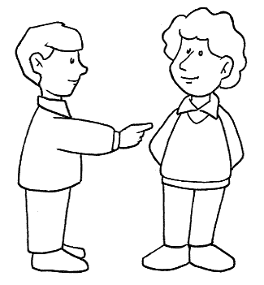 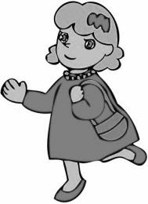

SHE / I

YOU / I

YOU / HE

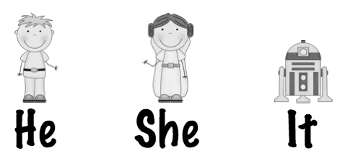 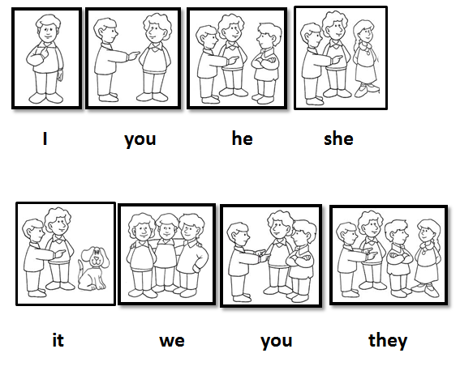

THEY / I

YOU / HE

**4.1 Worksheet**

Write the pronoun that is replaced in each sentence. *(She, He, They)*

1. My friends gave me a gift. ________________
2. My brother has a party. __________________
3. Ana is a smart girl. ___________________

**5.1 Worksheet**

**Sound vowels (long vowel sounds)**

Color the picture of each vowel and repeat the name pictures.

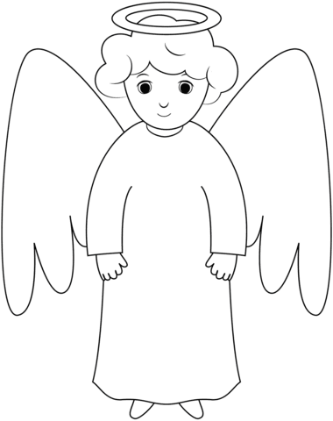  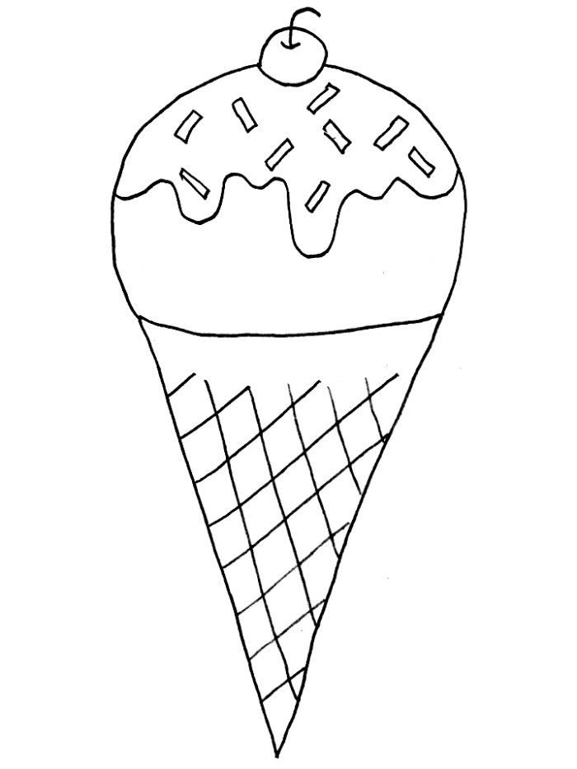

**Angel Ear Ice cream**

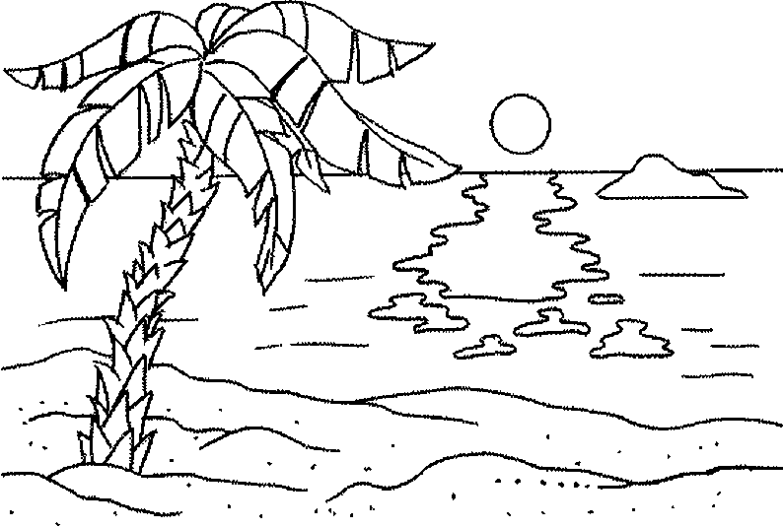 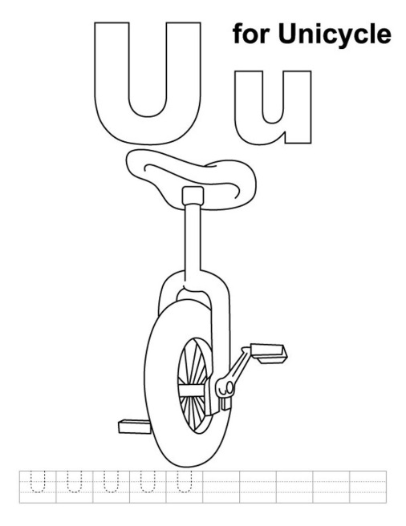

**Ocean Unicycle**

**5.1 Worksheet**

Match the vowel to the picture

a

e

o

i

u

Angel

Unicycle

Ocean

Ear

Ice cream

**6.1 Worksheet**

**Days of the week**

*On the Math notebook draw a chart and write the days in order.*

*Note:* Puede guiarse con el cuadro (chart) que puse anteriormente.

**6.2 Worksheet**

Follow the sequence. Need to write the day is next on the sequence.