República de Panamá

Ministerio de Educación

Educación Particular

Centro Educativo Bilingüe Bellas Luces

Date: **Monday 30 March to Friday 03** Teacher: Yinelli Núñez

**Módulo Mensual**

**SUBJECT: GRAMMAR** LEVEL: 9 GRADE

***“THE LORD IS WITH ME, I WILL NOT BE AFRAID, THE LORD IS WITH ME, HE IS MY HELPER” PSALM 118:6-7***

OBJECTIVE:

1. Understand the uses of adverbs and expressions of frequency.

**TOPIC: EXPRESSIONS OF FREQUENCY**

**EXPLANATION:**

Adverbs of frequency go **before** the main verb: I ***always*** come to work on time. Adverbs of frequency go **after** "be": They *are* **never** pleased to see me. Expressions of frequency (every day, twice a week, once a month etc) usually go at the end of a sentence:  
*I have English lessons****every day****.*

[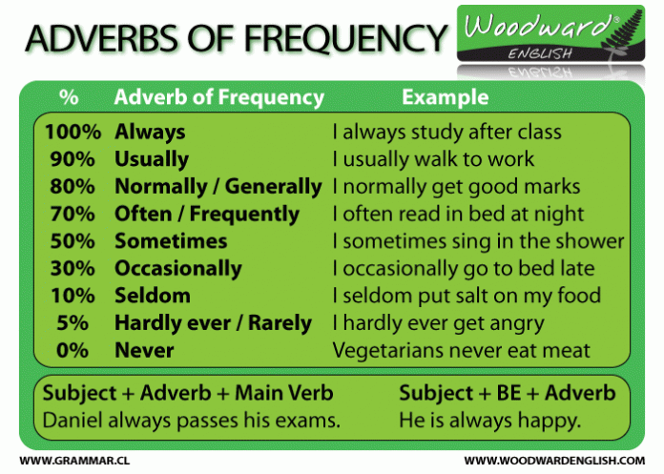](https://www.google.com/url?sa=i&url=http%3A%2F%2Fwww3.gobiernodecanarias.org%2Fmedusa%2Fecoblog%2Ffpelmel%2Fadverbs-of-frequency%2F&psig=AOvVaw1PqEWQ6U-oK6PEXMQP95JV&ust=1586092679630000&source=images&cd=vfe&ved=0CAIQjRxqFwoTCIChtOntzugCFQAAAAAdAAAAABAI)

¨

ACTIVITY: READ THE EXPLANATION, SEE THE VIDEO AND WRITE THE EXPRESSIONS OF FREQUENCY.), UNDERLINE EACH ONE WITH DIFFERENT COLOR.

1. **I ______________ go to the cinema. 90%**
2. **He ____________ plays football 100%**
3. **They ___________ have parties at their house. 50%**
4. **I have __________ gone to the beach. 100%**
5. **He has __________ been to Florida. 0%**
6. **They have ___________ done their homework before eating dinner. 100%**
7. **My puppy _____________ pees inside the house. 5%**
8. **Max ____________wants to work. 0%**
9. **I don't _____________ watch TV. 70%**
10. **Do you ______________travel? 90%**
11. **Are they _____________ at the beach? 50%**
12. **They don´ t ______________ watch TV. 90%**
13. **Her _____________eats sweets. 0%**
14. **They are _____________- in bed by 11:30 90%**
15. **She´s _____________ eaten Chinese food. 0%**
16. **Have you _______________ had a really serious illness? 5%**
17. **She ______________ put sugar on my coffee. 10%**

II. Write the meaning in Spanish of the adverb of frequency.

Never, Hardly ever, Rarely, Sometimes, Occasionally, Often, Regularly ,Usually

Normally, Always, Seldom

**TRADUCCION: LEER LA EXPLICACION, VER EL VIDEO, UBICAR EL PORCENTAJE PARA CADA ADVERVIO DE FRECUENCIA Y ESCRIBIRLO EN LA LINEA, DAR COLOR A CADA ADVERBIO. II PARTE: TRADUCIR EN ESPAÑOL LOS ADVERBIOS PARA RECONOCER SU SIGNIFICADO.**

República de Panamá

Ministerio de Educación

Educación Particular

Centro Educativo Bilingüe Bellas Luces

Date: **Monday 30 March to Friday 03** Teacher: Yinelli Núñez

**Módulo Mensual**

**SUBJECT: READING** LEVEL: 9 GRADE

***“THE LORD IS WITH ME, I WILL NOT BE AFRAID, THE LORD IS WITH ME, HE IS MY HELPER” PSALM 118:6-7***

OBJECTIVE:

1. Use the headings to find specific information.

TOPIC: Coffee with Milk, Sugar, and... Mushrooms!



Millions of people love coffee. They drink it every day. But is coffee healthy? Scientists don't agree on the answer. So, people are trying to make coffee healthy. Now there is a new kind of coffee - mushroom coffee!

*Chaga* is a kind of mushroom. It's black, and grows on trees. Chaga mushrooms are very healthy. They also have a lot of vitamins. In Finland, people make tea with chaga mushrooms. It helps them relax.

Tero Isokauppila is from Finland. He wanted to help people stay healthy. He mixed chaga mushrooms with instant coffee. People liked Isokauppila's special coffee. In 2012, Isokauppila started a company called *Four Sigmatic*. The company sells coffee with chaga and other mushrooms.

So, is mushroom coffee healthy? Scientists don't know yet. But we do know one thing.It has less caffeine than other coffee. Mushroom coffee is popular. But some people don't like the taste. They say it's better with lots of milk and sugar!

ACTIVITIES: READ THE STORY AND UNDERSTAND THEM. AFTER READ THE QUESTIONS AND ANSWER IN COMPLETE PHRASE.

QUESTIONARY #1

1. If mushroom coffee healthy?
2. How many people love coffee?
3. What country is Tero Isokauppila?
4. What say the people about the mushroom coffee?
5. What is Chaga?
6. Mention 3 characteristic about Chaga.
7. Mention the name of the company of Isokauppila and the year started.
8. Draw something you understand about the short history.

**TRADUCCION: LEER LA HISTORIA EN CASA EN VOZ ALTA, TRATAR DE COMPRENDER O TRADUCIRLA AL ESPAÑOL Y RESPONDER EN SU CUADERNO LAS PREGUNTAS.**

República de Panamá

Ministerio de Educación

Educación Particular

Centro Educativo Bilingüe Bellas Luces

Date: **Monday 30 March to Friday 03** Teacher: Yinelli Núñez

**Módulo Mensual**

**SUBJECT: SPELLING** LEVEL: 9 GRADE

***“THE LORD IS WITH ME, I WILL NOT BE AFRAID, THE LORD IS WITH ME, HE IS MY HELPER” PSALM 118:6-7***

OBJECTIVE:

1. Understand and recognize the meaning of the part of the computer in English.

Topic: PARTS OF THE COMPUTER. RASPBERRY PI.

INSTRUCTIONS ACTIVITIES: DRAW OR PRINT THE IMAGE AND WRITE THE PARTS OF THE COMPUTER. IF YOU HAVE YOUR STUDENTS BOOK LOOK THE PAGE 14.

1. Try to practice the pronunciation of the word and translate for the meaning.

Headphones, keyboard, microphone, monitor, screen, mouse, printer, speaker, usb port, webcam.

**TRADUCCION: VER EL VIDEO PARA LA EXPLICACION, LEER LAS PALABRAS PARA PRACTICAR PRONUNCIACION Y DIBUJAR UNA COMPUTADORA COLOCANDO LAS PARTES ESCRITAS EN EL RECUADRO. SI TIENE LIBRO VEA LA PAGINA 14, O PUEDE BUSCAR EN INTERNET.**