MINISTRY OF EDUCATION

EDUCATIONAL CENTER BILINGUAL BELLAS LUCES

ENGLISH WORKSHOP

FIRST TRIMESTER

TEACHER:

ERIC MARTINEZ B.

3°

2020

DEVELOPS THE NEXTS POINTS IN A BLANK PAGE

MATH SECTION

ROMAN NUMERALS

The Roman Symbols

Romans Numerals are based on the following symbols:

|  |  |  |  |  |
| --- | --- | --- | --- | --- |
| 1 | 5 | 10 | 50 | 100 |
| I | V | X | L | C |

Basic Combinations

Which can be combined like this:

|  |  |  |  |  |  |  |  |  |
| --- | --- | --- | --- | --- | --- | --- | --- | --- |
| ONE | TWO | THREE | FOUR | FIVE | SIX | SEVEN | EIGHT | NINE |
| I | II | III | IV | V | VI | VII | VIII | IX |
|  |  |  |  |  |  |  |  |  |
| TEN | TWENTY | THIRTY | FOURTY | FIFTY |
| X | XX | XXX | XL | L |

Forming Numbers - The Rules

When a symbol appears **after a larger** (or equal) symbol it is **added**

Example: VI = V + I = 5 + 1 = 6

Example: LXX = L + X + X = 50 + 10 + 10 = 70

But if the symbol appears **before a larger** symbol it is **subtracted**

Example: IV = V − I = 5 − 1 = 4

Example: IX = X − I = 10 − 1 = 9

ACTIVITY:

1. WRITE THE NUMBER OR THE ROMAN NUMERAL:

III ____________________

FIFTY ______

XL _______________

TEN _____

IV _____

**TYPES OF POLYGONS**

Polygons can be classified according to their number of sides:

Triangle: polygon with three sides

Quadrilateral: polygon with four sides

Pentagon: polygon with five sides

Hexagon: polygon with six sides

Heptagon: polygon with seven sides

Octagon: polygon with eight sides

Nonagon: polygon with nine sides

Decagon: polygon with ten sides

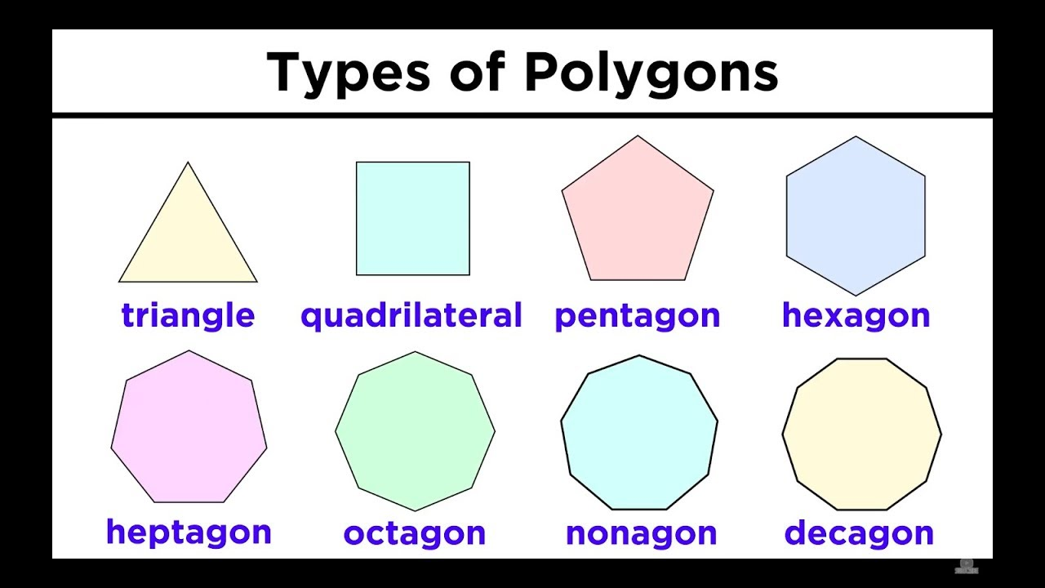

ACTIVITY:

1. ACCORDING WITH THE INFORMATION COMPLETE THE NEXT CHART AND DRAW THE POLYGON

|  |  |  |
| --- | --- | --- |
| POLYGON WITH… | WRITE THE POLYGON | DRAW THE POLYGON |
| FOUR SIDES | QUADRILATERAL |  |
| TEN SIDES |  |  |
|  |  |  |
|  | TRIANGLE |  |
| EIGHT SIDES |  |  |
|  | HEPTAGON |  |